**Approach and Process**

1. What in my process and approach to this project would I do differently next time?  
     
   Allocate time better/properly. Leaving more time to deploy on server and run full tests on production. This will leave me with more time to troubleshoot any problems out of development.  
     
   Also allocate more time to design and clean up the CSS.
2. What in my process and approach to this project went well that I would repeat next time?  
     
   MVC process. Its clean and clear as to exactly where each of the items should go.

**Code and Code Design**

1. What in my code and program design in the project would I do differently next time?  
     
   have a more indepth user experience flow. Ensuring all elements are present(e.g. log out button.)  
     
   Step by step on which buttons/section on each of the pages, what do they require, what do they do.
2. What in my code and program design in the project went well? Is there anything I would do the same next time?  
     
   Planning the data types in SQL, querying on dates and extraction.  
     
   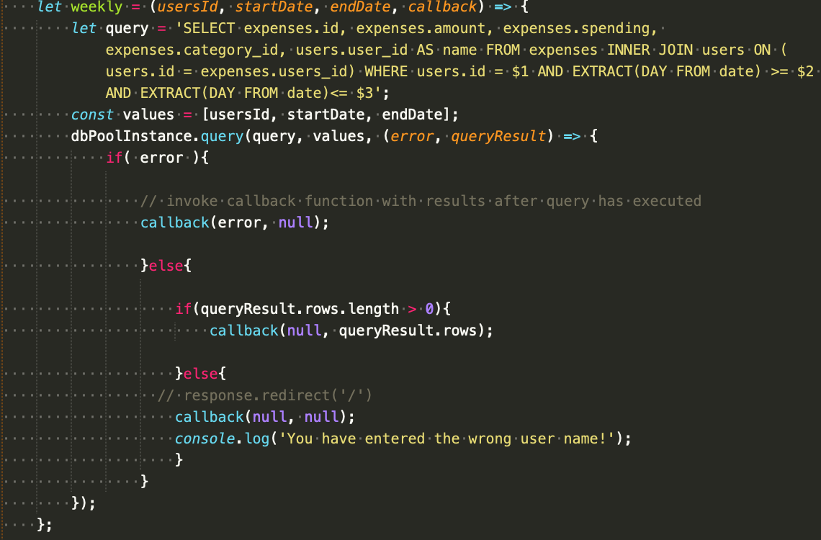

For each, please include code examples.

1. Code snippet up to 20 lines.
2. Code design documents or architecture drawings / diagrams.  
     
   -- refer to other word doc.

**WDI Unit 2 Post Mortem**

1. What habits did I use during this unit that helped me?  
     
   breaking down the app into smaller workable parts along. Working them in below order -> routes> controllers> models> views.
2. What habits did I have during this unit that I can improve on?  
     
   Time management> leave more time for deployment
3. How is the overall level of the course during this unit? (instruction, course materials, etc.)  
     
   Quite high, need to catch quite a bit up on the MVC part.